OPERATION FALSE ASSURANCE

Phase 1 Investigation Report -- Fraudulent Verification and Script Delivery
Team Name | BYEBUST
Phase | Phase 1 -- Fraudulent Verification and Script Delivery
Incident Date (UTC) | 2025-10-01
Date Submitted | 2026-08-22

Challenge 1 of 10: Affected Workstation and DNS Resolver
Investigation Question: Identify the affected workstation IPv4 address and the DNS resolver it used.

Brief Explanation
One computer on the network got hacked. Its number-name is 160.9.3.101. To visit any website, a computer must first ask a helper computer for directions - this is called a DNS server. This computer's helper was 160.9.3.1.

Technical Method
Query used: event.dataset:"zeek.dns" AND destination.port:53 | groupby source.ip
Enumerated all hosts issuing real (unicast, port 53) DNS queries across every imported evidence batch, filtering out LLMNR/NBNS/mDNS broadcast noise (ports 137/5355). This Security Onion instance contains 11 separate import batches; the correct Phase 1 evidence is import batch 495ee14fa7e950512fce637bcc361290, the only one dated 2025-10-01, matching the scenario's stated timeframe. Of the October-2025-dated hosts, 160.9.3.101 has the earliest activity (2025-10-01 09:00:00 UTC), and 51 of its 53 real DNS queries went to resolver 160.9.3.1.

Supporting Evidence (Security Onion / Zeek)
- log.id.uid: CuhnDu3ogRkMIJxGHh
- source.ip: 160.9.3.101, source.port: 52322
- destination.ip (resolver): 160.9.3.1, destination.port: 53
- @timestamp: 2025-10-01T09:00:00.000Z

Answer
Workstation: 160.9.3.101 | DNS Resolver: 160.9.3.1
Submitted flag: CTK{160.9.3.101|160.9.3.1}

Containment Recommendations
- Isolate workstation 160.9.3.101 from the network pending full forensic review.
- Preserve DNS resolver logs on 160.9.3.1 for correlation with other hosts.

Conclusion
This finding establishes the affected workstation (160.9.3.101) and its DNS resolver (160.9.3.1) as the foundation for the rest of the Phase 1 investigation.

Evidence Screenshots

Figure 1a - Query Step
The Security Onion query used to begin this part of the investigation, and its result list.
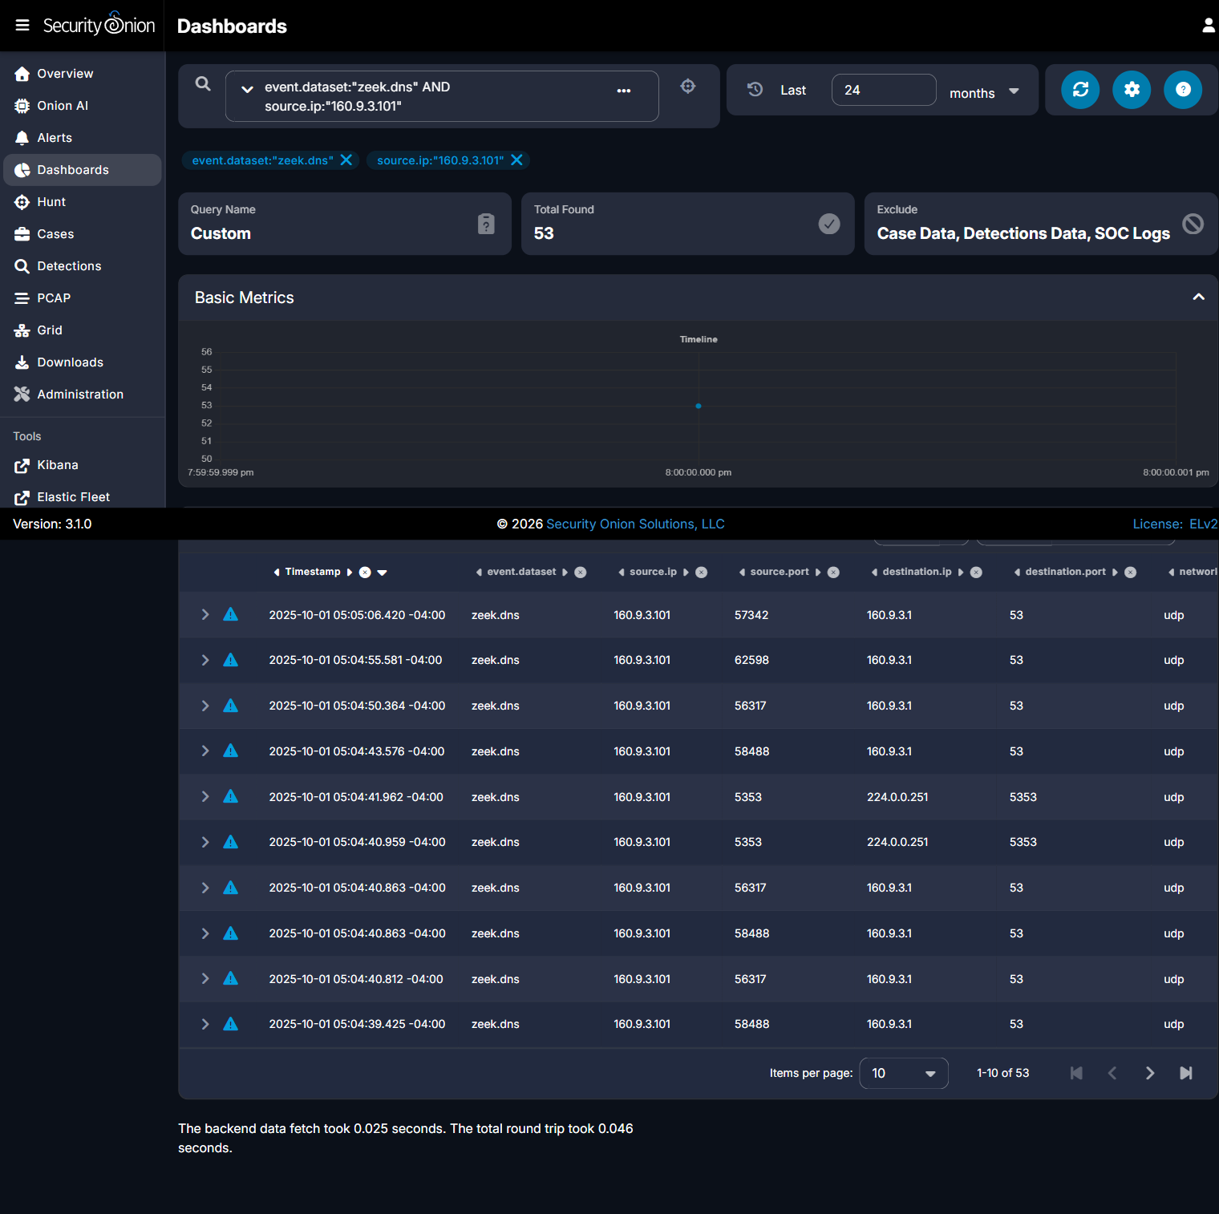


Figure 1b - Evidence Step
The specific record expanded, showing the timestamp that produced the answer above.

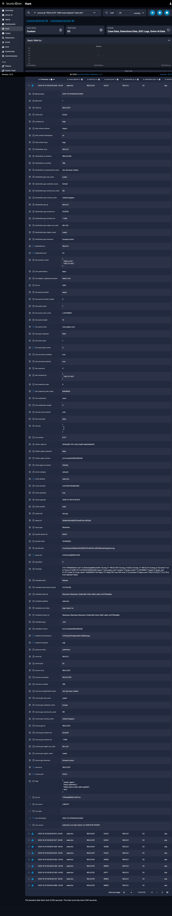

Challenge 2 of 10: First Web Domain
Investigation Question: What was the first web domain queried by the workstation, and what IPv4 address was returned?

Brief Explanation
The very first thing the computer did was visit a website called www.sepco.com. That website looked real but was actually a trick, made to look like a 'verification' page. The trick website's address was 148.72.11.102.

Technical Method
Query used: source.ip:"160.9.3.101" sorted ascending by Timestamp
Sorted all events for 160.9.3.101 (all datasets) ascending by timestamp. The very first record for this host is a zeek.dns query at exactly 2025-10-01 09:00:00.000 UTC - the deliberate start-of-capture marker - resolving www.sepco.com to a single, unambiguous IPv4.

Relevant Infrastructure
Type | Domain / IP | Port | Purpose / Observation
Fraudulent Verification Page | www.sepco.com (148.72.11.102) | 443 | First site visited; the fake verification lure

Supporting Evidence (Security Onion / Zeek)
- log.id.uid: CuhnDu3ogRkMIJxGHh
- dns.query.name: www.sepco.com
- dns.resolved_ip: [148.72.11.102] (single answer, no ambiguity)
- @timestamp: 2025-10-01T09:00:00.000Z

Answer
Domain: www.sepco.com | IP Address: 148.72.11.102
Submitted flag: CTK{www.sepco.com|148.72.11.102}

Containment Recommendations
- Block www.sepco.com and 148.72.11.102 at DNS/web proxy and perimeter firewall.
- Search enterprise DNS logs for other hosts resolving www.sepco.com.

Conclusion
The workstation's initial compromise began with the fraudulent verification page www.sepco.com (148.72.11.102), matching the scenario's described lure.

Evidence Screenshots

Figure 2a - Query Step
The Security Onion query used to begin this part of the investigation, and its result list.
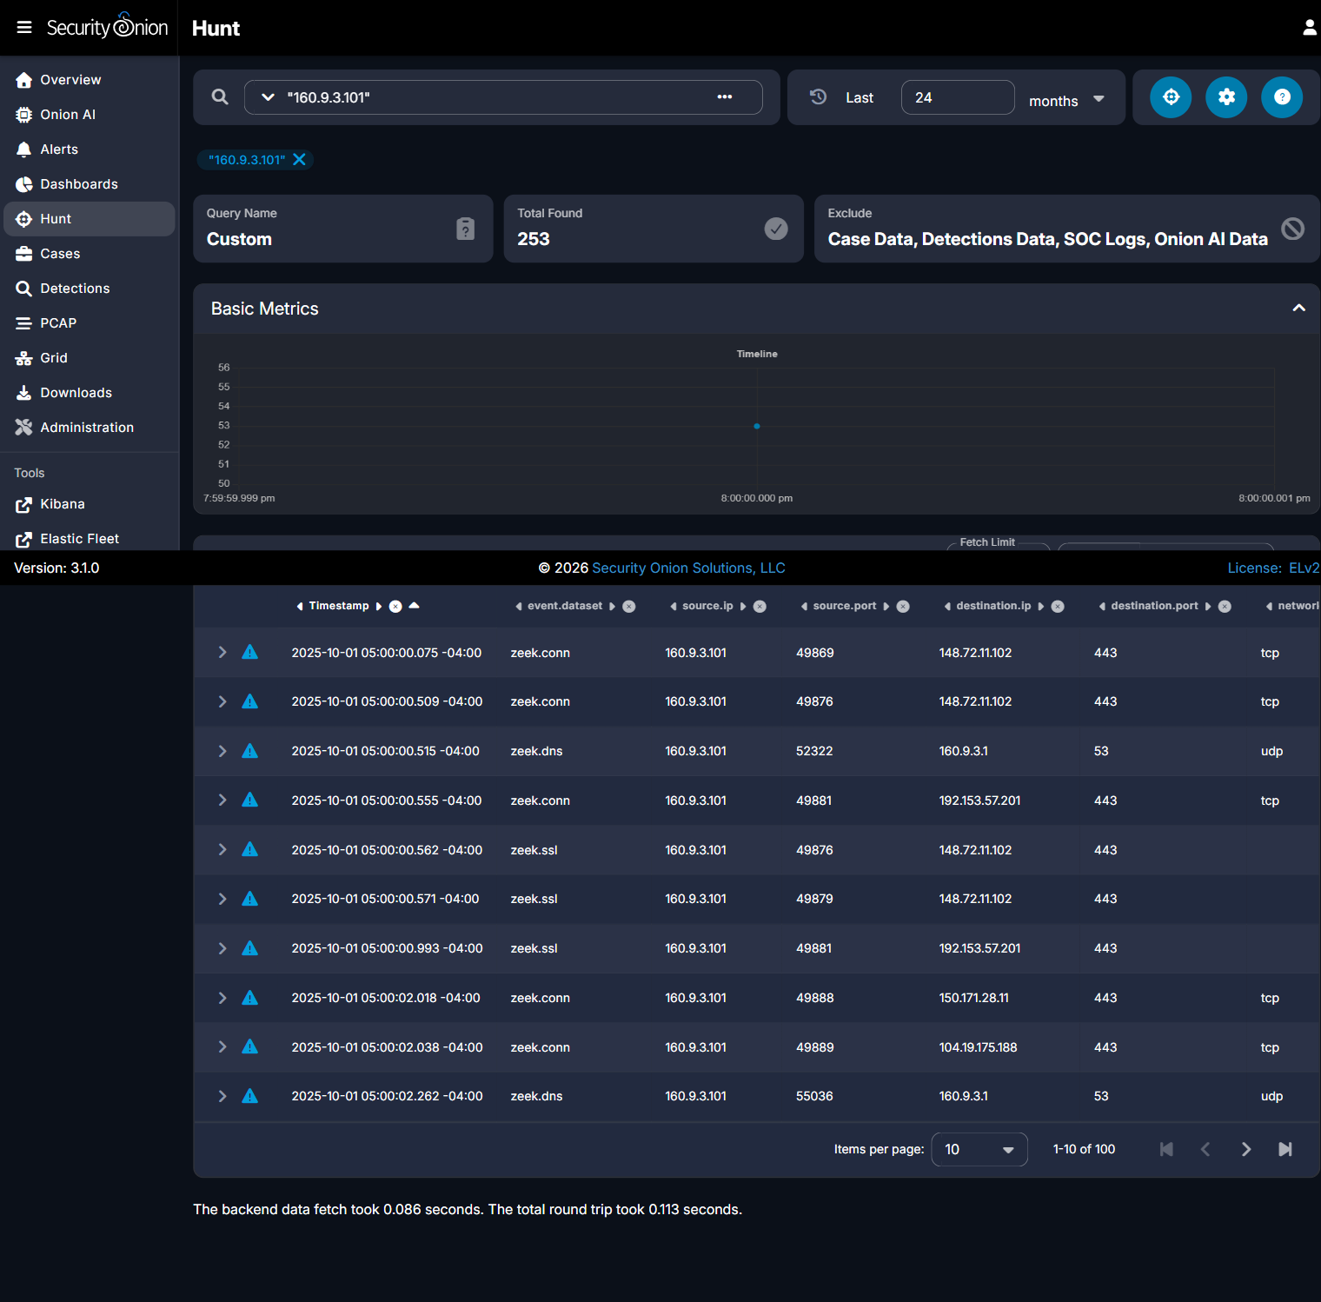


Figure 2b - Evidence Step
The specific record expanded, showing the details that produced the answer above.
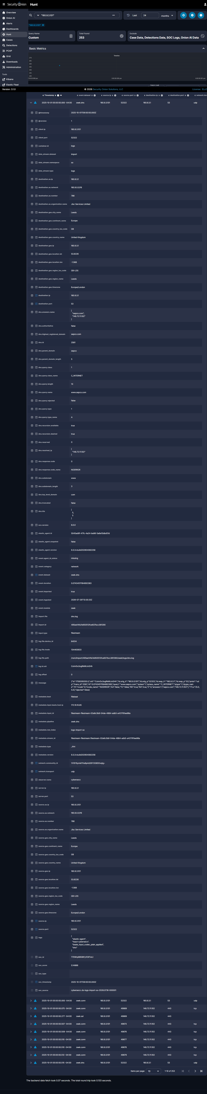


Challenge 3 of 10: Next TLS Server Name
Investigation Question: Which TLS server name appeared immediately after the first website, and what IPv4 address did it use?

Brief Explanation
Right after the trick website, the computer was sent to a second, different website - without anyone clicking anything. That second website was called louglas.com, at address 192.153.57.201.

Technical Method
Query used: source.ip:"160.9.3.101" AND event.dataset:"zeek.ssl"
Pulled all zeek.ssl events for the affected workstation, ascending by timestamp. After six parallel TLS sessions to www.sepco.com (148.72.11.102), the next distinct TLS server_name is louglas.com at 192.153.57.201, seen at 2025-10-01 09:00:00.993 UTC.

Relevant Infrastructure
Type | Domain / IP | Port | Purpose / Observation
Redirect / Second-stage Site | louglas.com (192.153.57.201) | 443 | Site contacted immediately after the verification page

Supporting Evidence (Security Onion / Zeek)
- log.id.uid: CPyXoy4rWDbQ1I1fY4
- ssl.server_name: louglas.com, ssl.version: TLSv1.2
- destination.ip: 192.153.57.201, destination.port: 443
- @timestamp: 2025-10-01T09:00:00.993Z

Answer
Domain: louglas.com | IP Address: 192.153.57.201
Submitted flag: CTK{louglas.com|192.153.57.201}

Containment Recommendations
- Block louglas.com and 192.153.57.201 at DNS/web proxy and perimeter firewall.
- Review TLS SNI logs enterprise-wide for other hosts contacting louglas.com.

Conclusion
louglas.com represents the transition point from the fraudulent verification page to the attacker's script-delivery infrastructure.

Evidence Screenshots

Figure 3a - Query Step
The Security Onion query used to begin this part of the investigation, and its result list.
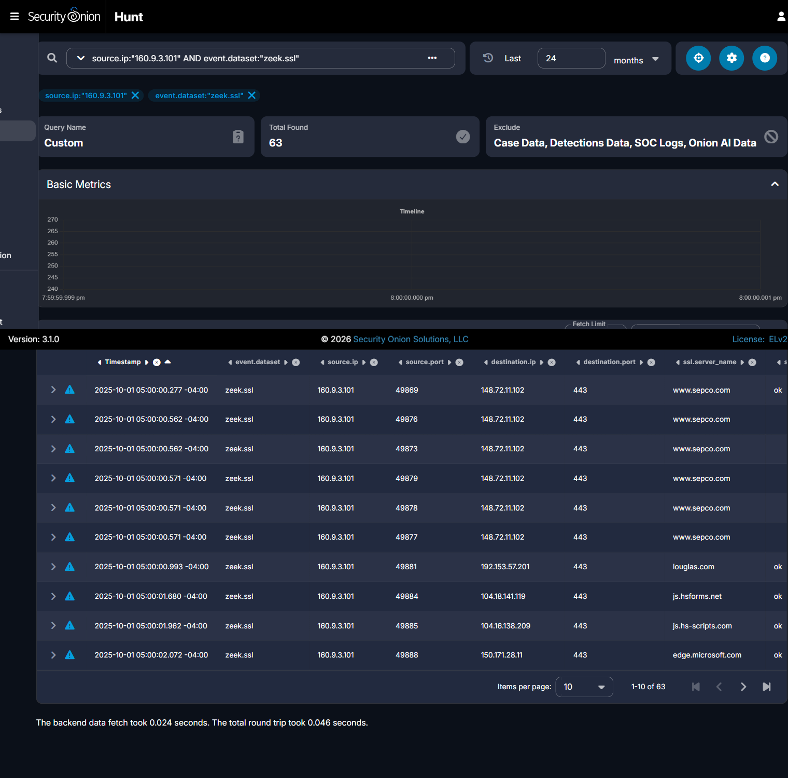


Figure 3b - Evidence Step
The specific record expanded, showing the details that produced the answer above.
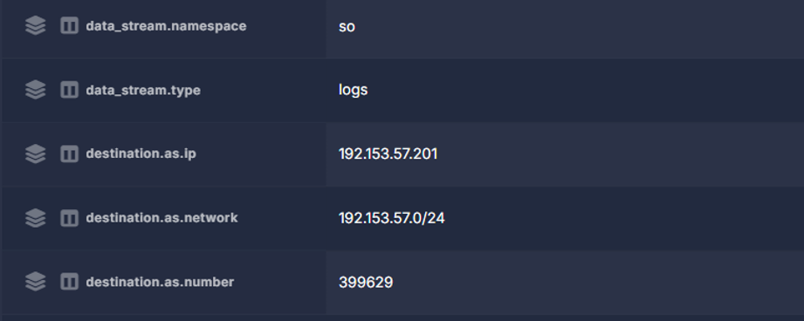

Challenge 4 of 10: PowerShell Delivery Server
Investigation Question: Identify the IPv4 address and TCP port of the server that delivered the PowerShell-related files.

Brief Explanation
A bad computer far away sent two harmful files to the victim's computer. That bad computer's address was 85.209.129.105. It used a special 'door' (called a port) numbered 2020 to send the files - not the normal doors websites use.

Technical Method
Query used: source.ip:"160.9.3.101" AND event.dataset:"zeek.file"
Pulled all zeek.file records for the affected workstation. scriptv2.ps1 and test.ps1 (PowerShell scripts) and a ~26 MB test.zip payload were all delivered from 85.209.129.105 over TCP port 2020 (non-standard HTTP port).

Relevant Infrastructure
Type | Domain / IP | Port | Purpose / Observation
Script & Payload Delivery Server | 85.209.129.105 | 2020 | Served both PowerShell scripts and the 26 MB archive; hosted in Finland

Malware / Tool Identification
PowerShell script delivery (scriptv2.ps1, test.ps1) via HTTP on non-standard port 2020, consistent with a lightweight HTTP file server used as attacker staging infrastructure.

Supporting Evidence (Security Onion / Zeek)
- destination.ip: 85.209.129.105, destination.port: 2020
- file.name: scriptv2.ps1, test.ps1
- file.mime_type: text/plain
- @timestamp: 2025-10-01T09:00:47.505Z (scriptv2.ps1)

Answer
Server: 85.209.129.105 | Port: 2020
Submitted flag: CTK{85.209.129.105|2020}

Containment Recommendations
- Block 85.209.129.105 (all ports, especially TCP/2020) at the perimeter firewall.
- Hunt enterprise-wide for any other host contacting 85.209.129.105.

Conclusion
85.209.129.105:2020 functioned as the central staging/delivery server for both PowerShell scripts and the large archive payload in this intrusion.

Evidence Screenshots

Figure 4a - Query Step
The Security Onion query used to begin this part of the investigation, and its result list.
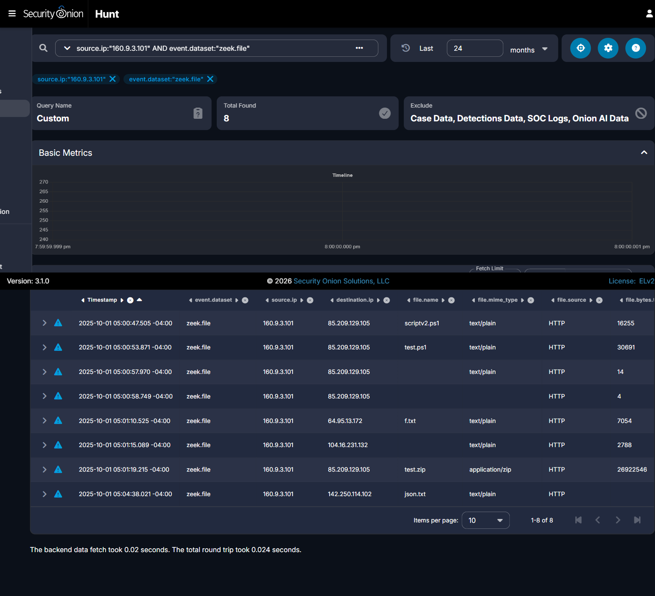


Figure 4b - Evidence Step
The specific record expanded, showing the details that produced the answer above.

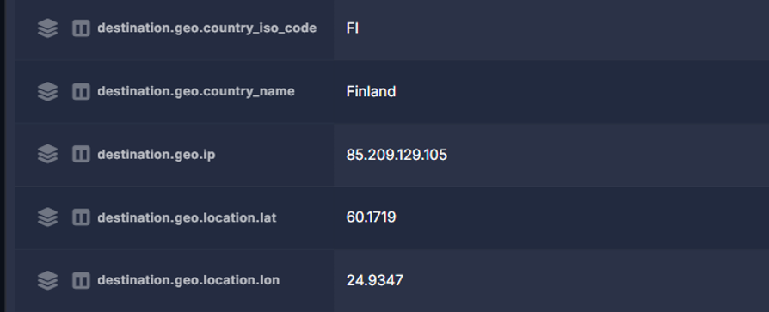
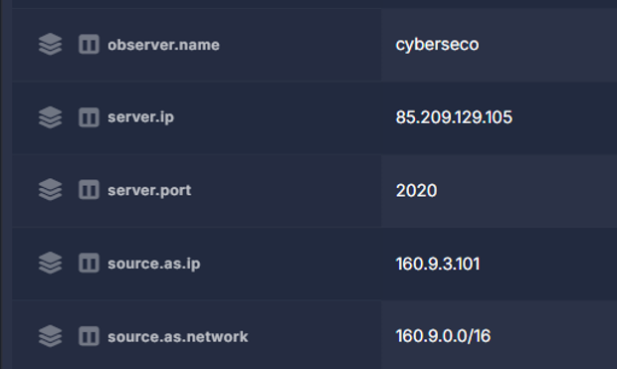

Challenge 5 of 10: First Script Delivery
Investigation Question: What URI delivered the first script, and what filename was recorded for the response?

Brief Explanation
The first harmful file was named scriptv2.ps1. It is a small program written for Windows PowerShell (a tool built into Windows for running commands). It was fetched from a specific spot on the bad computer called /19.

Technical Method
Query used: source.ip:"160.9.3.101" AND event.dataset:"zeek.http"
Listed all zeek.http events for the affected workstation, ascending by timestamp. The first HTTP request to the delivery server (05:00:47.201 -04:00) was GET /19 (curl/8.14.1 user-agent), 200 OK, returning file scriptv2.ps1 (16,255 bytes).

Malware / Tool Identification
First-stage script scriptv2.ps1 retrieved via curl (not yet PowerShell), suggesting an initial loader/dropper stage distinct from the workstation's own PowerShell process.

Supporting Evidence (Security Onion / Zeek)
- log.id.uid: CqGE2b39Yb7ePbbQ25
- http.method: GET, http.uri: /19
- http.useragent: curl/8.14.1
- file.resp_filenames: scriptv2.ps1
- @timestamp: 2025-10-01T09:00:47.201Z

Answer
URI: /19 | Filename: scriptv2.ps1
Submitted flag: CTK{/19|scriptv2.ps1}

Containment Recommendations
- Add URI pattern /19 on 85.209.129.105:2020 to IDS/WAF detection rules.
- Search endpoint/EDR telemetry for scriptv2.ps1 execution on other hosts.

Conclusion
URI /19 on the delivery server marks the first script-delivery event in the intrusion chain, recorded under the filename scriptv2.ps1.

Evidence Screenshots

Figure 5a - Query Step
The Security Onion query used to begin this part of the investigation, and its result list.
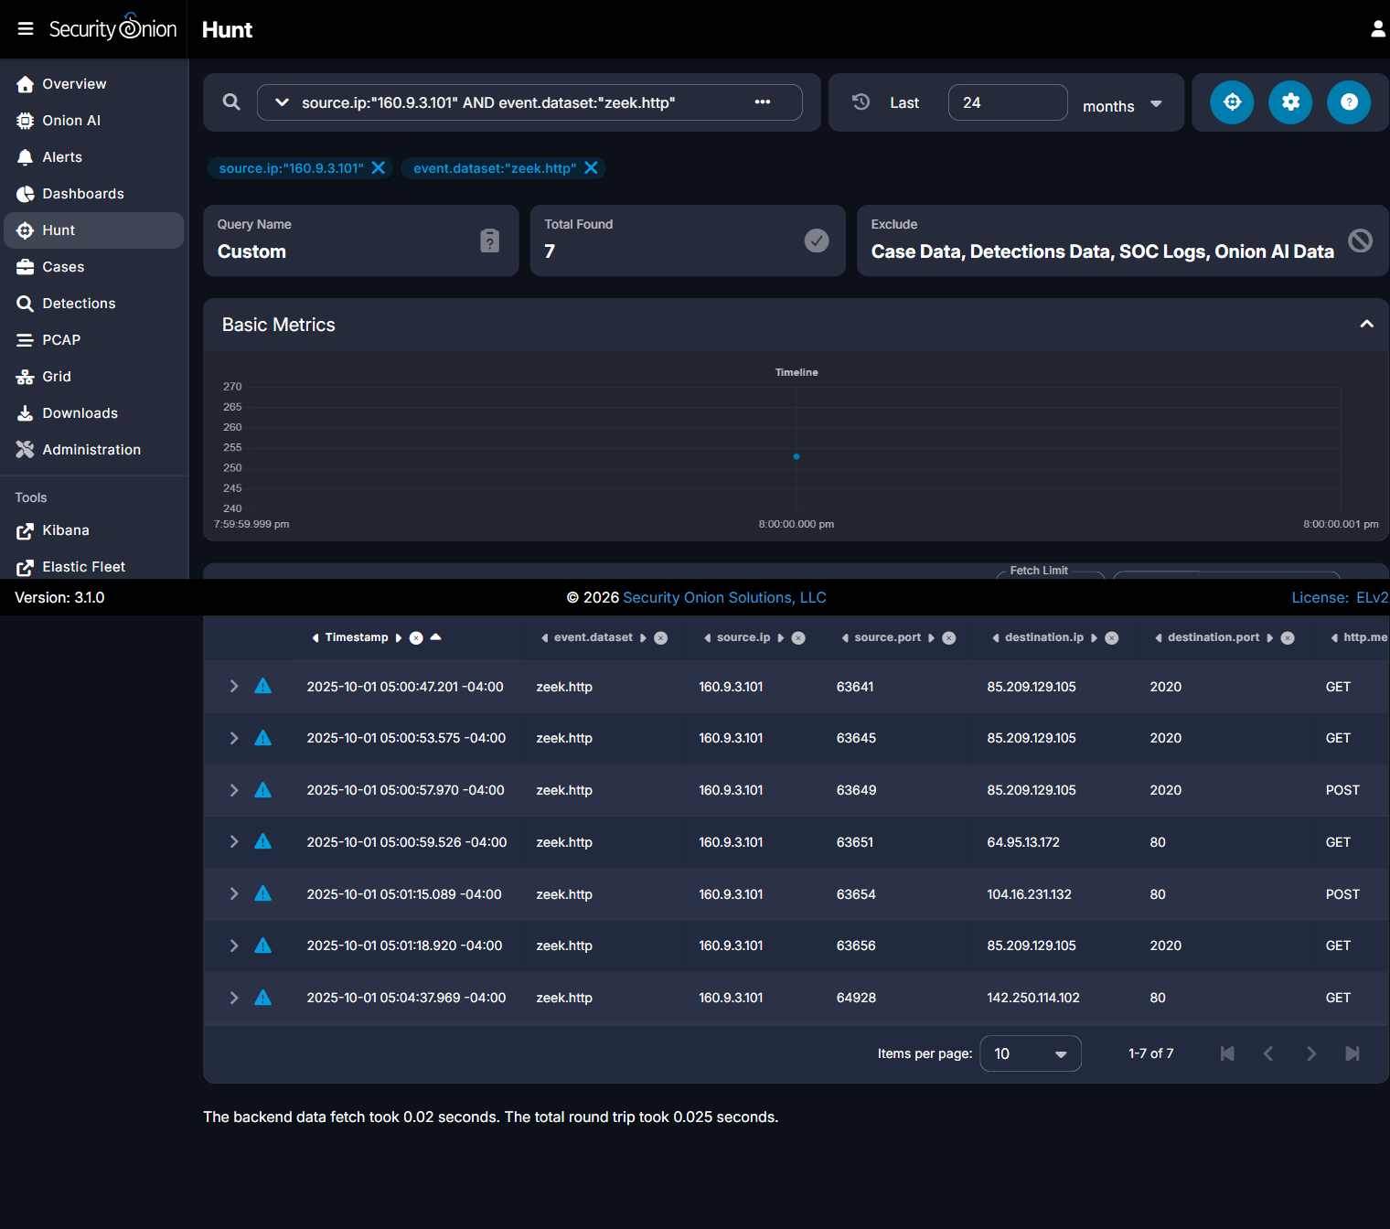


Figure 5b - Evidence Step
The specific record expanded, showing the details that produced the answer above.
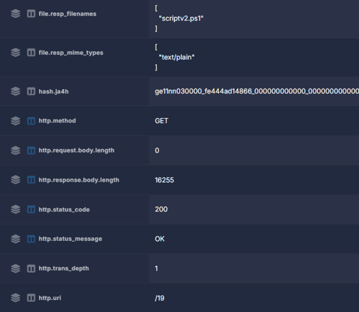

Challenge 6 of 10: Second Script Delivery
Investigation Question: What URI delivered the second script, and what filename was recorded for the response?

Brief Explanation
A second harmful file came next. It was named test.ps1, and it came from a spot called /test112. This time, it was Windows PowerShell itself - not a person or a simple tool - that grabbed the file.

Technical Method
Query used: source.ip:"160.9.3.101" AND event.dataset:"zeek.http"
The second HTTP request to the delivery server (05:00:53.575 -04:00) was GET /test112, this time using a genuine WindowsPowerShell/5.1.26100.4768 user-agent, returning file test.ps1 (30,691 bytes) - indicating the first script had already executed.

Malware / Tool Identification
Second-stage script test.ps1 retrieved by a genuine PowerShell process, indicating scriptv2.ps1 executed and initiated this follow-on download.

Supporting Evidence (Security Onion / Zeek)
- log.id.uid: Cktb803yzkrrCkYDyc
- http.method: GET, http.uri: /test112
- http.useragent: WindowsPowerShell/5.1.26100.4768
- file.resp_filenames: test.ps1
- @timestamp: 2025-10-01T09:00:53.575Z

Answer
URI: /test112 | Filename: test.ps1
Submitted flag: CTK{/test112|test.ps1}

Containment Recommendations
- Add URI pattern /test112 on 85.209.129.105:2020 to IDS/WAF detection rules.
- Enable PowerShell script block logging on 160.9.3.101 and similar hosts.

Conclusion
The change in user-agent between the first (curl) and second (genuine PowerShell) requests is a key indicator that scriptv2.ps1 executed and autonomously fetched test.ps1.

Evidence Screenshots

Figure 6a - Query Step
The Security Onion query used to begin this part of the investigation, and its result list.



Figure 6b - Evidence Step
The specific record expanded, showing the details that produced the answer above.

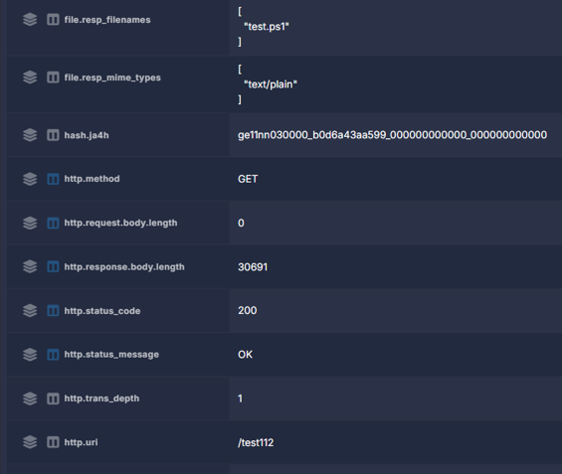

Challenge 7 of 10: Notification Request
Investigation Question: Which HTTP method and URI were used for the notification request, and what response status was returned?

Brief Explanation
After the files ran, the victim's computer sent a tiny message back to the bad computer, almost like saying 'it worked!' The message went to a spot called /notify, and the bad computer answered back 'OK'.

Technical Method
Query used: source.ip:"160.9.3.101" AND event.dataset:"zeek.http"
POST /notify to 85.209.129.105:2020 at 2025-10-01 09:00:57.970 UTC; 14-byte request, 4-byte response, status 200 OK - a beacon/check-in confirming script execution.

Command-and-Control Assessment
POST /notify (14-byte request, 4-byte response) is assessed as a lightweight C2 check-in/beacon confirming successful execution of the delivered PowerShell scripts.

Supporting Evidence (Security Onion / Zeek)
- log.id.uid: C8kmUG21ryBXI6qCA8
- http.method: POST, http.uri: /notify
- http.status_code: 200
- @timestamp: 2025-10-01T09:00:57.970Z

Answer
Method: POST | URI: /notify | Response Status: 200
Submitted flag: CTK{POST|/notify|200}

Containment Recommendations
- Add URI pattern /notify on 85.209.129.105:2020 to IDS/WAF detection rules as a beacon indicator.

Conclusion
The /notify POST request functions as a check-in beacon, marking the point at which the attacker's infrastructure was informed that script execution succeeded on the victim host.

Evidence Screenshots

Figure 7a - Query Step
The Security Onion query used to begin this part of the investigation, and its result list.



Figure 7b - Evidence Step
The specific record expanded, showing the details that produced the answer above.
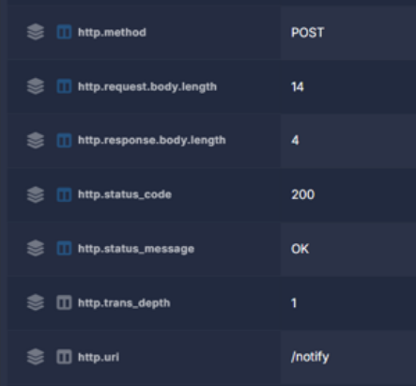

Challenge 8 of 10: Cloudflare Tunnel Transaction
Investigation Question: Identify the Cloudflare Tunnel hostname, POST URI, and response status code.

Brief Explanation
The attacker also used a free, temporary 'tunnel' from Cloudflare (a real, trusted company) to hide where they truly were. It was used only once, and the far end said 'not found'.

Technical Method
Query used: source.ip:"160.9.3.101" AND event.dataset:"zeek.http"
POST /BSVjy5VpVrgO to maintaining-shelter-bailey-ordinance.trycloudflare.com at 2025-10-01 09:01:15.089 UTC; 2,788-byte request, 404 Not Found response.

Relevant Infrastructure
Type | Domain / IP | Port | Purpose / Observation
Disposable Relay | maintaining-shelter-bailey-ordinance.trycloudflare.com | 80 | Temporary Cloudflare Tunnel used to relay a POST request; hides the true backend

Command-and-Control Assessment
Use of a trycloudflare.com quick-tunnel (auto-generated random subdomain) to relay a POST request is a known technique for hiding the true backend C2 server behind Cloudflare's legitimate infrastructure.

Supporting Evidence (Security Onion / Zeek)
- log.id.uid: Cp61j16BYOZNBVlca
- http.method: POST, http.uri: /BSVjy5VpVrgO
- http.virtual_host: maintaining-shelter-bailey-ordinance.trycloudflare.com
- http.status_code: 404
- @timestamp: 2025-10-01T09:01:15.089Z

Answer
Hostname: maintaining-shelter-bailey-ordinance.trycloudflare.com | URI: /BSVjy5VpVrgO | Status: 404
Submitted flag: CTK{maintaining-shelter-bailey-ordinance.trycloudflare.com|/BSVjy5VpVrgO|404}

Containment Recommendations
- Block the specific trycloudflare.com hostname at DNS/web proxy.
- Alert on any *.trycloudflare.com traffic enterprise-wide as a detection rule.

Conclusion
The Cloudflare Tunnel transaction demonstrates the attacker's use of disposable, legitimate-looking infrastructure to relay traffic, complicating IP-based blocking.

Evidence Screenshots

Figure 8a - Query Step
The Security Onion query used to begin this part of the investigation, and its result list.



Figure 8b - Evidence Step
The specific record expanded, showing the details that produced the answer above.
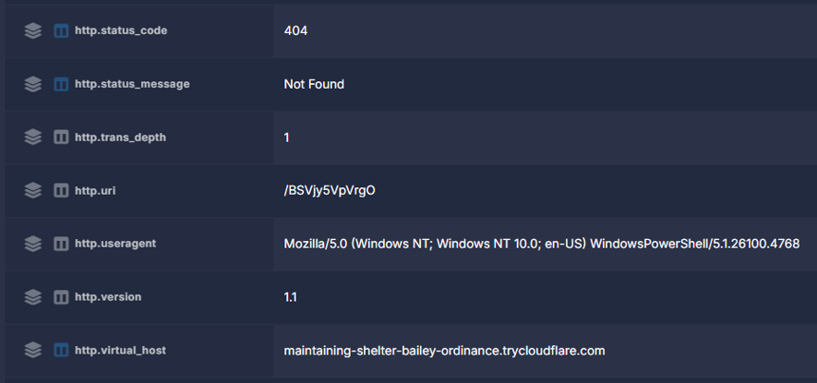

Challenge 9 of 10: Large Archive Transfer
Investigation Question: What URI delivered the large archive? Provide the recorded filename and response body size.

In Plain Words
The biggest file sent was a large zipped folder - about 26 megabytes, roughly the size of a few hundred photos - named test.zip. It came from a spot called /testl11.

Technical Method
Query used: source.ip:"160.9.3.101" AND event.dataset:"zeek.http"
GET /testl11 to 85.209.129.105:2020 at 2025-10-01 09:01:18.920 UTC; 200 OK, response body 26,922,546 bytes, recorded filename test.zip (application/zip), matching the zeek.file record exactly.

Malware / Tool Identification
A large (~26 MB) archive, test.zip, delivered as the final payload - likely containing a secondary implant or tooling given its size relative to the earlier plaintext scripts.

Supporting Evidence (Security Onion / Zeek)
- log.id.uid: C2qZ713cWuXatbYjDb
- http.method: GET, http.uri: /testl11
- http.response.body.length: 26922546
- file.name: test.zip, file.mime_type: application/zip
- @timestamp: 2025-10-01T09:01:18.920Z

Answer
URI: /testl11 | Filename: test.zip | Size: 26,922,546 bytes
Submitted flag: CTK{/testl11|test.zip|26922546}

Containment Recommendations
- Add URI pattern /testl11 on 85.209.129.105:2020 to IDS/WAF detection rules.
- If PCAP retention allows, carve and sandbox-analyze test.zip.

Conclusion
The ~26 MB test.zip archive represents the largest and likely most consequential payload delivered in the Phase 1 chain.

Evidence Screenshots

Figure 9a - Query Step
The Security Onion query used to begin this part of the investigation, and its result list.



Figure 9b - Evidence Step
The specific record expanded, showing the details that produced the answer above.

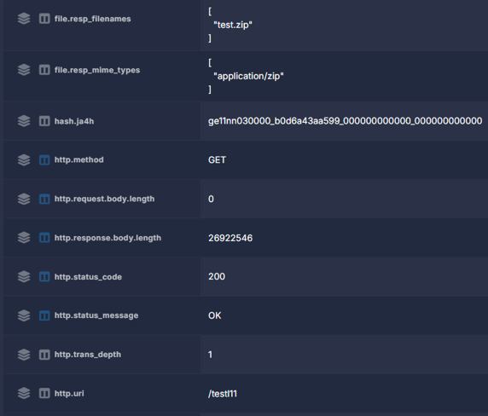

Challenge 10 of 10: Later TLS C2 Domain
Investigation Question: Which later TLS server name resolved to 91.212.166.160?

In Plain Words
After everything else happened, the victim's computer kept quietly calling out to a website named georgej.ru, again and again - nine times in under a minute. This kind of repeated, automatic calling out is how attackers secretly stay in control of a computer they have hacked.

Technical Method
Query used: source.ip:"160.9.3.101" AND destination.ip:"91.212.166.160" AND event.dataset:"zeek.ssl"
Queried all zeek.ssl sessions from the affected workstation to 91.212.166.160. Found 9 separate TLSv1.3 sessions between 09:04:35.412 and 09:05:06.643 UTC, all carrying ssl.server_name: georgej.ru.

Relevant Infrastructure
Type | Domain / IP | Port | Purpose / Observation
Command-and-Control Server | georgej.ru (91.212.166.160) | 443 | Repeatedly contacted (9 times) after script execution - the ongoing remote-control channel

Command-and-Control Assessment
georgej.ru (91.212.166.160) was contacted 9 times over TLSv1.3 within a ~31 second window, a pattern consistent with periodic C2 beaconing rather than normal browsing, occurring after the script-delivery and notification chain.

Supporting Evidence (Security Onion / Zeek)
- log.id.uid: Cayp7x1osJH5m9henj (first of 9 sessions)
- destination.ip: 91.212.166.160, destination.port: 443
- ssl.server_name: georgej.ru, ssl.version: TLSv1.3
- @timestamp: 2025-10-01T09:04:35.412Z (first occurrence)

Answer
Domain: georgej.ru (resolves to 91.212.166.160)
Submitted flag: CTK{georgej.ru}

Containment Recommendations
- Block georgej.ru and 91.212.166.160 at DNS/web proxy and perimeter firewall immediately.
- Prioritize this host for full endpoint forensic imaging given confirmed C2 activity.

Conclusion
The repeated TLS beaconing to georgej.ru (91.212.166.160) confirms an active command-and-control channel was established on the affected workstation - the most operationally significant finding of Phase 1.

Evidence Screenshots

Figure 10a - Query Step
The Security Onion query used to begin this part of the investigation, and its result list.
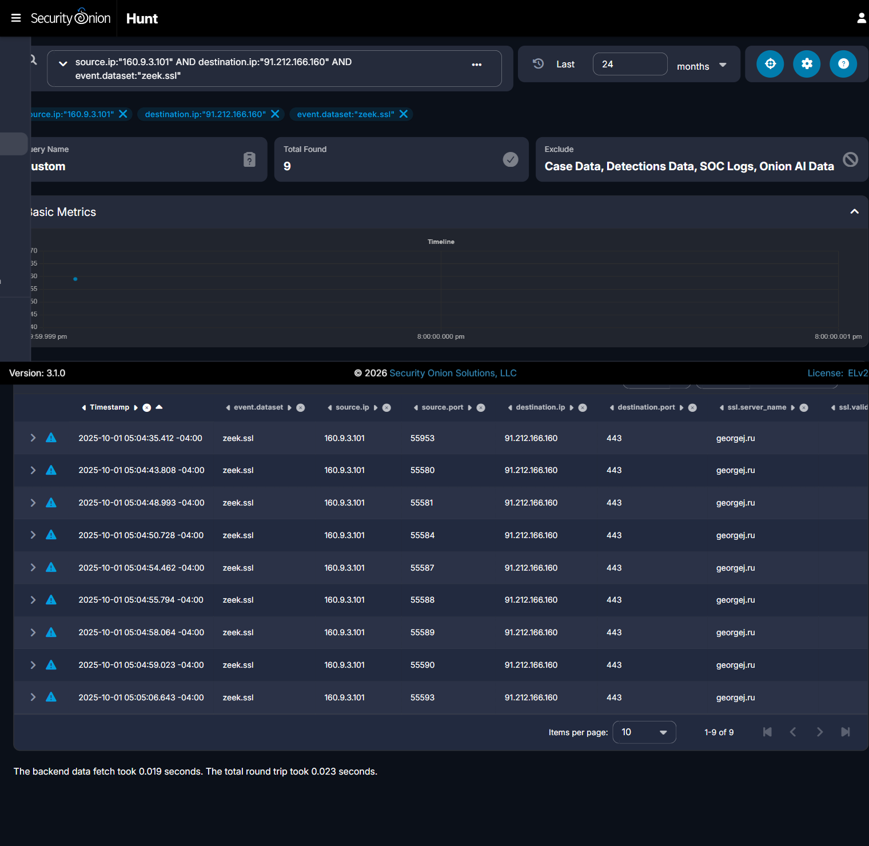


Figure 10b - Evidence Step
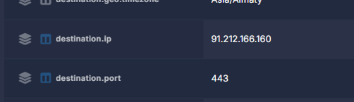
The specific record expanded, showing the details that produced the answer above.

